

OOP Lab #4

SUBMITTED BY:
UBAID AHMAD
ROLL NO:
2410-0011
SUBMITTED TO:
Mam Laiba Tanveer
DATE:
14/10/2025

Example 1 shallow copy
Code:
#include <iostream>
using namespace std;
class student{
private:
string name;
int age;
public:
student(){
age=23;
}
student(string n,int a){
name=n;
age=a;
}
operator=(student &s){
name=s.name;
age=s.age;
}
void display(){
cout<<"name is: "<<name<<endl;
cout<<"age is:: "<<age<<endl;
}

~student(){
name="null";
age=0;
cout<<name<<" "<<age<<endl;
}
};
int main(){
student s1;
student s2("ahmad",20);
cout<<"------------student 1"<<endl;
s1.display();
cout<<"------------student 2"<<endl;
s2.display();
s1=s2;
cout<<"------------student 1"<<endl;
s1.display();
cout<<"------------student 2"<<endl;
s2.display();
}
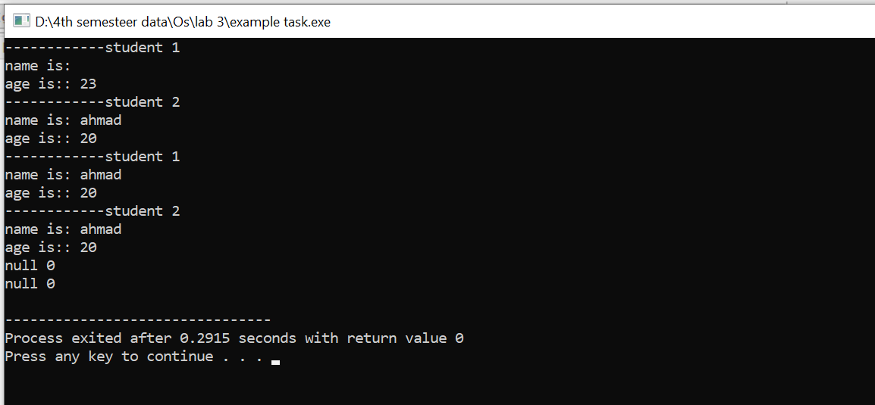

Example 1 shallow copy
Code:
#include <iostream>
using namespace std;

class student {
private:
string name;
public:

int* age;

student() {
name = "empty";
age = new int(23);
}

student(string n, int a) {
name = n;
age = new int(a);
}

student& operator=(student& s) {
name = s.name;
age = new int(*s.age);

}
void display() {
cout << "name is: " << name << endl;
cout << "age is: " << *age << endl;
}
~student() {
delete age;
}
};

int main() {
student s1;
student s2("ahmad", 20);

cout << "------------student 1" << endl;
s1.display();
cout << "------------student 2" << endl;
s2.display();

s1 = s2;

cout << "------------After assignment------------" << endl;
cout << "student 1" << endl;
s1.display();
cout << "student 2" << endl;
s2.display();
*(s2.age)=13;
cout << "------------After assignment------------" << endl;
cout << "student 1" << endl;
s1.display();
cout << "student 2" << endl;
s2.display();
return 0;
}
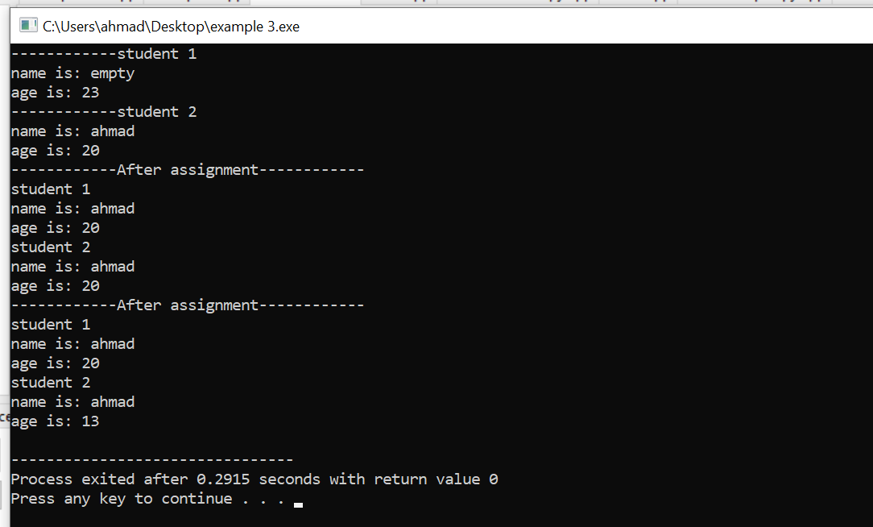

Example 2 Box deep copy
Code:
#include <iostream>
using namespace std;
class Box{
private:
int length;
int *breadth;
int height;
public:
Box(){
breadth=new int;
}

void setDimensions(int l,int b,int h){
length=l;
*breadth=b;
height=h;
}
Box(Box &b){
length=b.length;
breadth=b.breadth; //passed by reference
height=b.height;
}
void showData(){
cout<<"length : "<<length<<endl;
cout<<"beadth : "<<*breadth<<endl;
cout<<"height : "<<height<<endl;
}

};
int main(){
Box b1;
b1.setDimensions(4,5,6);
Box b2(b1);
cout<<"--------------before modifying"<<endl;
cout<<"\n-----box 1:----"<<endl;
b1.showData();
cout<<"------box 2:----"<<endl;
b2.showData();

b1.setDimensions(10,11,12);
cout<<"\n--------------before modifying"<<endl;
cout<<"\n-----box 1:----"<<endl;
b1.showData();
cout<<"------box 2:----"<<endl;
b2.showData();
return 0;
}
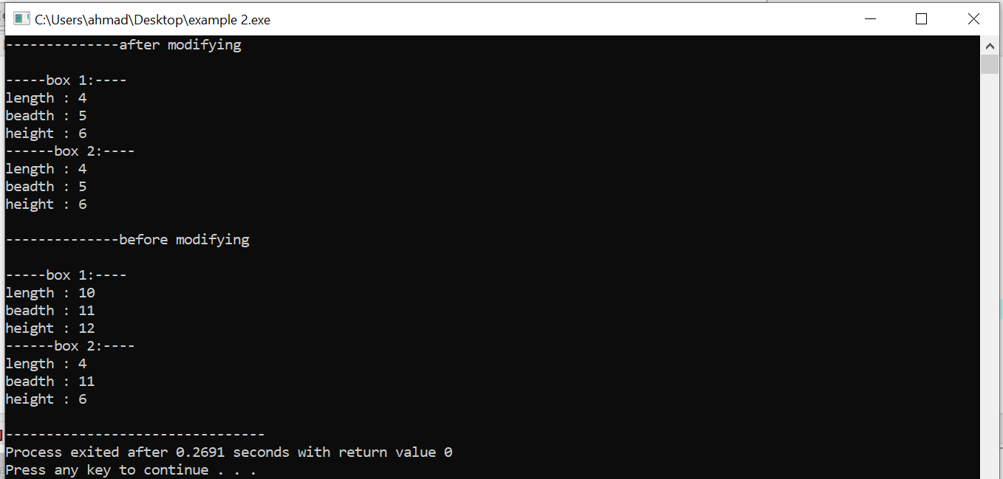

Task 1 shallow copy
Code:
#include <iostream>
using namespace std;

class polygon {
public:
float length;
float* width;

polygon(float a, float b) {
length = a;
width = new float(b);
}

polygon(polygon &p) {
length = p.length;
width = p.width;
}
void display() {
cout << "length is: " << length << endl;
cout << "width is : " << *width << endl;
}
~polygon() {
delete width;
}
};

int main() {
polygon one(4.0, 5.0);
polygon two(one);
cout << "--------------------------Initial values----" << endl;
cout<<"\n----------object one--"<<endl;
one.display();
cout<<"\n----------object two--"<<endl;
two.display();
cout << "\n------------------------Changing one's data----" << endl;

one.length = 6;
*one.width = 10;
cout<<"\n----------object one--"<<endl;
one.display();
cout<<"\n----------object two--"<<endl;
two.display();
return 0;
}
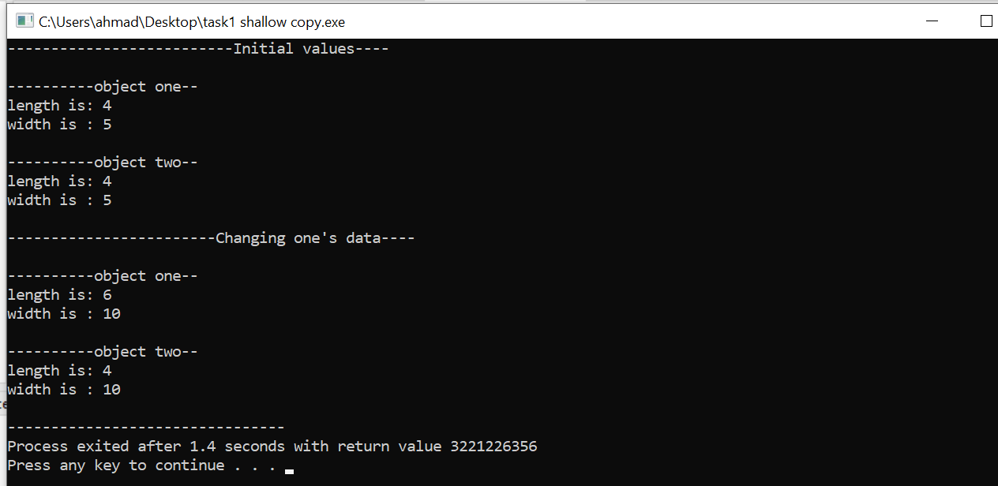
Task 1 deep copy
Code:
#include <iostream>
using namespace std;
class polygon{
public:
float length;
float width;

polygon(float a,float b){
length=a;
width=b;
}

polygon(polygon &p){
length=p.length;
width=p.width;
}
void display(){
cout<<" length is: "<<length<<endl;
cout<<" width is : "<<width<<endl;
}
};
int main(){
polygon one(4.0,5.0);
polygon two(one);
cout<<"----------object one--"<<endl;
one.display();
cout<<"----------object two--"<<endl;
two.display();
//modifying object one length;
one.length=6;
cout<<"-----------------------after modifying object one length"<<endl;
cout<<"\n----------object one--"<<endl;
one.display();
cout<<"----------object two--"<<endl;
two.display();
return 0;

}
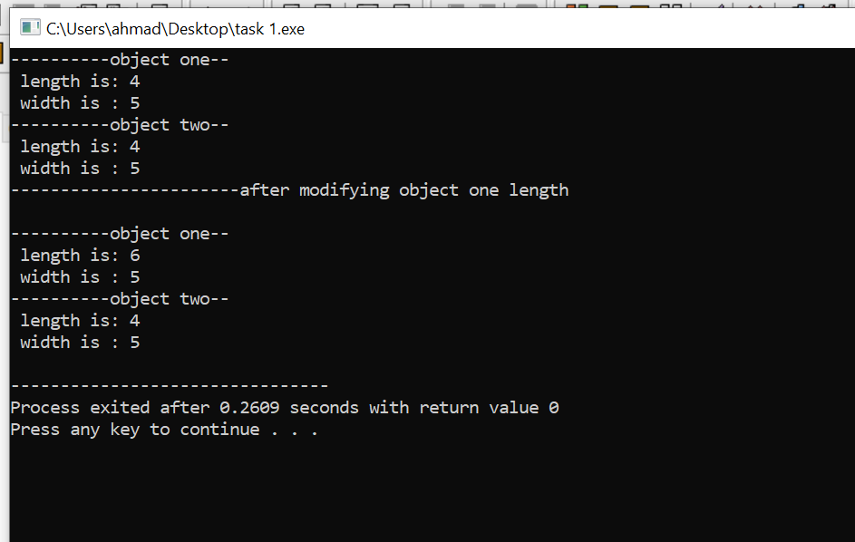

Task 2 shallow copy
Code:
#include <iostream>
using namespace std;
class student {
int Id;
int size;

public:
float* grades;

student(int n) {
size = n;
grades = new float[size];
}

void readData() {
cout << "Enter student ID: ";
cin >> Id;
cout << "Enter " << size << " grades: ";
for (int i = 0; i < size; i++) {
cin >> grades[i];
}
}
student(student &s) {
Id = s.Id;
size = s.size;
grades = s.grades;
}
void display() {
cout << "\nStudent ID: " << Id << endl;
cout << "Grades: ";
for (int i = 0; i < size; i++) {
cout << grades[i] << " ";
}
cout << endl;
}

~student() {
delete[] grades;
}
};
int main() {
student s1(5);
s1.readData();
student s2(s1);
cout << "\nBefore changing s1:\n";
s1.display();
s2.display();

s1.readData();
cout << "\nAfter changing s1:\n";
s1.display();
s2.display();

return 0;
}
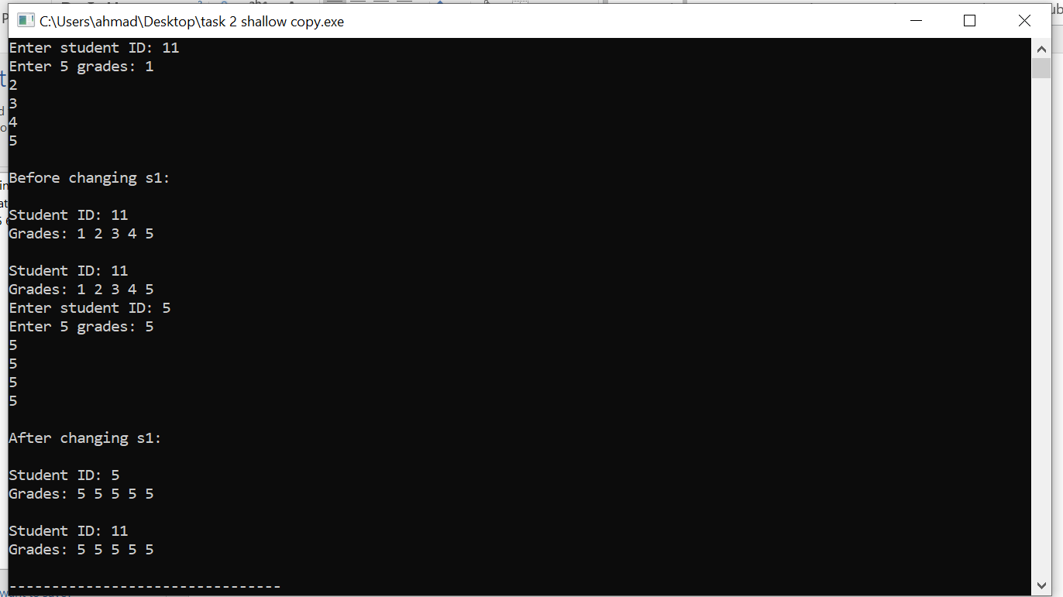

Task 2 deep copy
Code:
#include <iostream>
using namespace std;

class student {
int Id;
int size;

public:
float* grades;

student(int n) {
size = n;
grades = new float[size];
}

void readData() {
cout << "Enter student ID: ";
cin >> Id;
cout << "Enter " << size << " grades: ";
for (int i = 0; i < size; i++) {
cin >> grades[i];
}
}

student(student &s) {
Id = s.Id;
size = s.size;
grades = new float[size];
for (int i = 0; i < size; i++) {
grades[i] = s.grades[i];
}
}

void display() {
cout << "\nStudent ID: " << Id << endl;
cout << "Grades: ";
for (int i = 0; i < size; i++) {
cout << grades[i] << " ";
}
cout << endl;
}

~student() {
delete[] grades;
}
};

int main() {
student s1(5);
s1.readData();

student s2(s1);

cout << "\nBefore changing s1:\n";
s1.display();
s2.display();

s1.readData();

cout << "\nAfter changing s1:\n";
s1.display();
s2.display();

return 0;
}
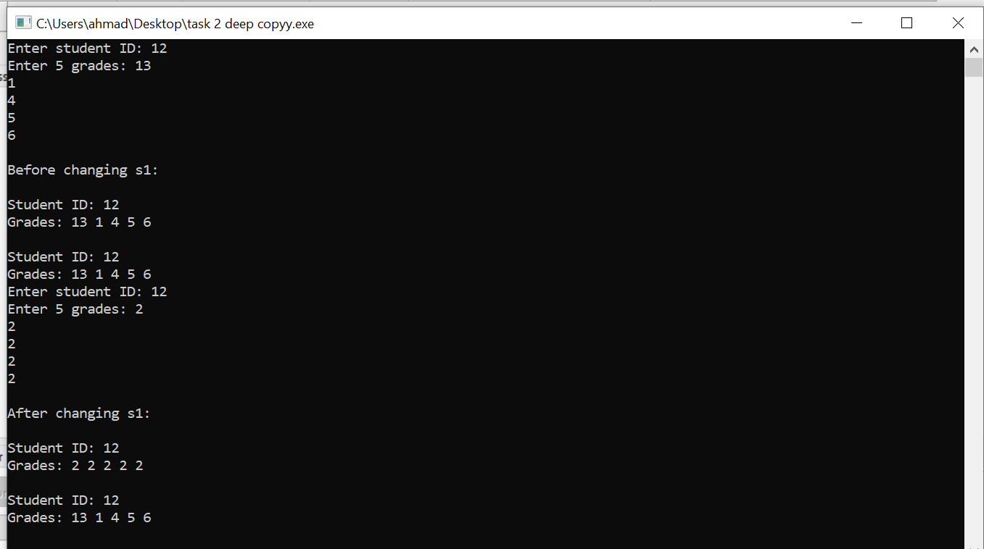

END,,,

